Use-case for CP QUERY NAMES

The output of the CP QUERY NAMES command
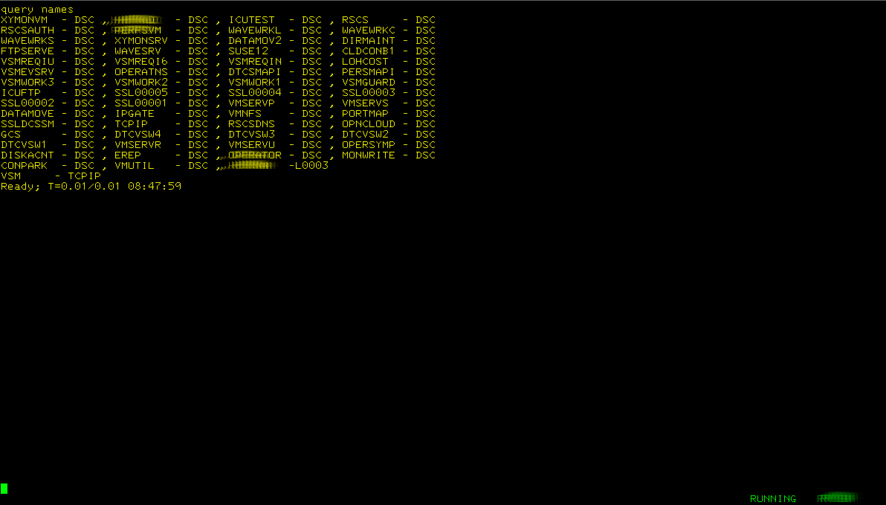
I want to display all the user ids on the system in alphabetical order
because I do not like the output of the CP QUERY NAMES command.

/* QN EXEC, query names sorted */
'PIPE (end ?)',
'cp QUERY NAMES', /* Ask CP who is logged on */
'| split at ,', /* Split the records at the comma */
'| strip', /* Remove spaces on both ends */
'| sort 1.8', /* Sort on user name */
'| cons' /* Put the results on the console */


I hate using the clear key to clean the screen so I want it in 4 columns
/* QN EXEC, query names sorted and in 4 columns */
'PIPE (end ?)',
'cp QUERY NAMES', /* Ask CP who is logged on */
'| split at ,', /* Split the records at the comma */
'| sort 1.8', /* Sort on user name */
'| snake 4', /* Create 4 columns */
'| cons' /* Put the results on the console */
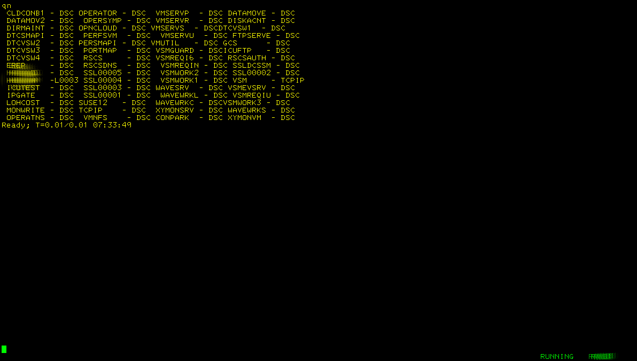
Being not happy with this layout I want it in neat columns
/* QN EXEC, query names sorted, in 4 columns and aligned */
'PIPE (end ?)',
'cp QUERY NAMES', /* Ask CP who is logged on */
'| split at ,', /* Split the records at the comma */
'| strip', /* Remove spaces on both ends */
'| sort 1.8', /* Sort on user name */
'| specs pad space 1;* 1.22', /* Pad each record upto 22 chars with blanks */
'| snake 4', /* Create 4 columns */
'| cons' /* Put the results on the console */
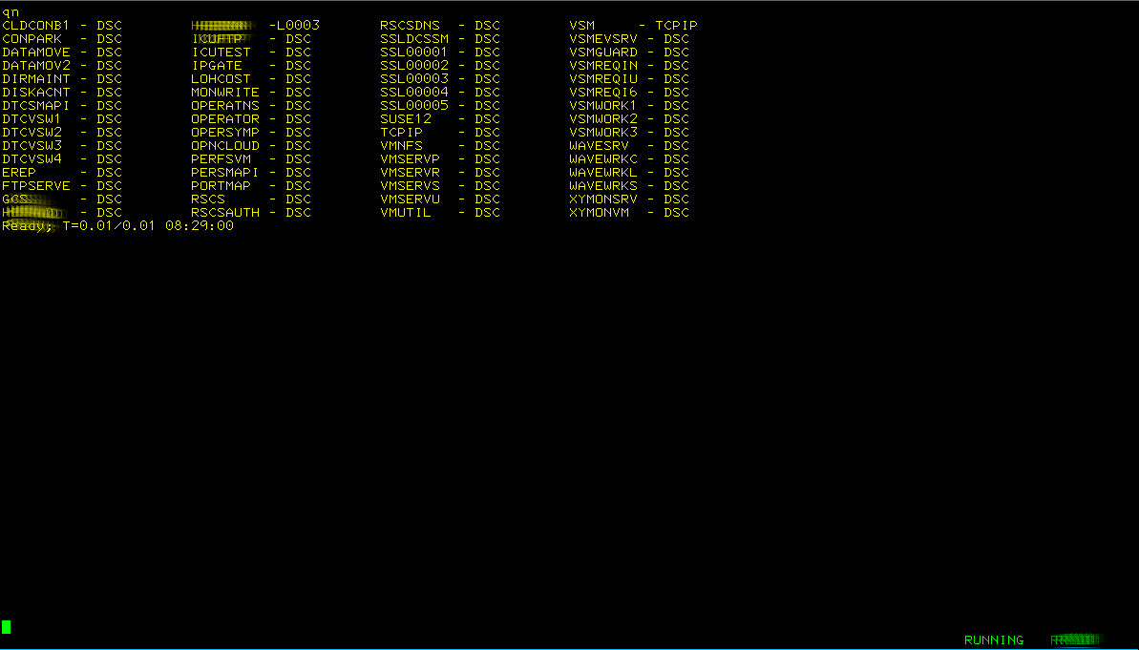
Now I see there is one entry that does not represent a user id and I want removed.
/* QN EXEC, query names sorted, in 4 columns, aligned and cleaned */
'PIPE (end ?)',
'cp QUERY NAMES', /* Ask CP who is logged on */
'| split at ,', /* Split the records at the comma */
'| strip', /* Remove spaces on both ends */
'| sort 1.8', /* Sort on user name */
'| pick w1.1 \== /VSM/ and', /* Select records were word 1 is not equal to..*/
'w3.1 \== /TCPIP/', /* ...and word 3 is not equal to... */
'| specs pad space 1;* 1.22', /* Pad each record upto 22 chars */
'| snake 4', /* Create 4 columns */
'| cons' /* Put the results on the console */
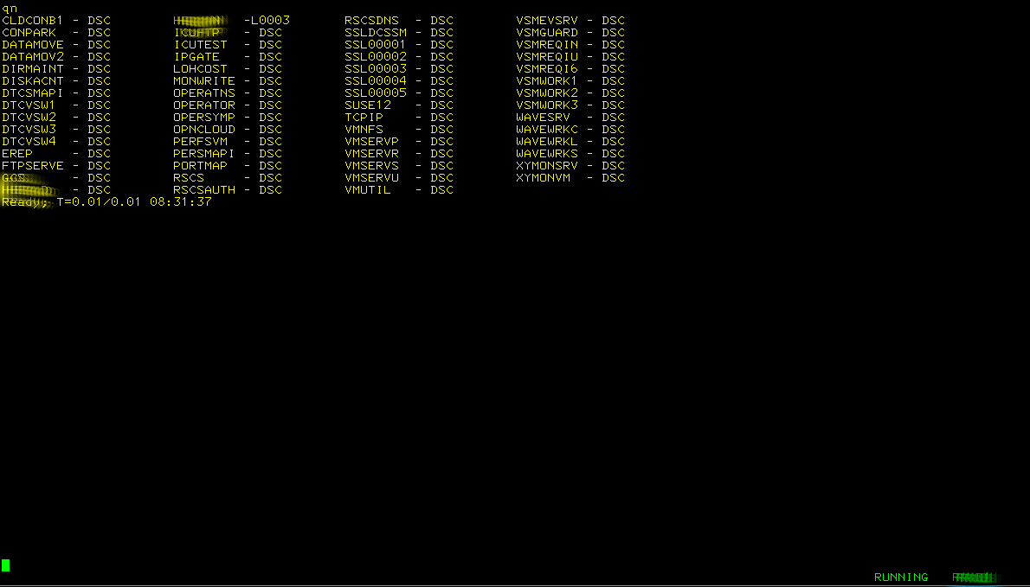

I wonder how many user ids are on the system?
/* QN EXEC, query names sorted, in 4 columns, aligned, cleaned & counted */
'PIPE (end ?)',
'cp QUERY NAMES', /* Ask CP who is logged on */
'| split at ,', /* Split the records at the comma */
'| strip', /* Remove spaces on both ends */
'| sort 1.8', /* Sort on user name */
'| pick w1.1 \== /VSM/ and', /* Select records were word 1 is not equal to... */
'w3.1 \== /TCPIP/', /* ...and word 3 is not equal to... */
'| fo: fanout', /* Send the records to label fo: */
'| specs pad space 1;* 1.22', /* Pad each record upto 22 chars */
'| snake 4', /* Create 4 columns */
'| fi: faninany', /* Take in from label fi: */
'| cons', /* Put the results on the console */
'? fo:', /* Take records from fanout */
'| count lines', /* Count the ids */
'| specs /User ids on the system/ 1 w1.1 nw', /* Add some text */
'| fi:' /* Send to faninany */

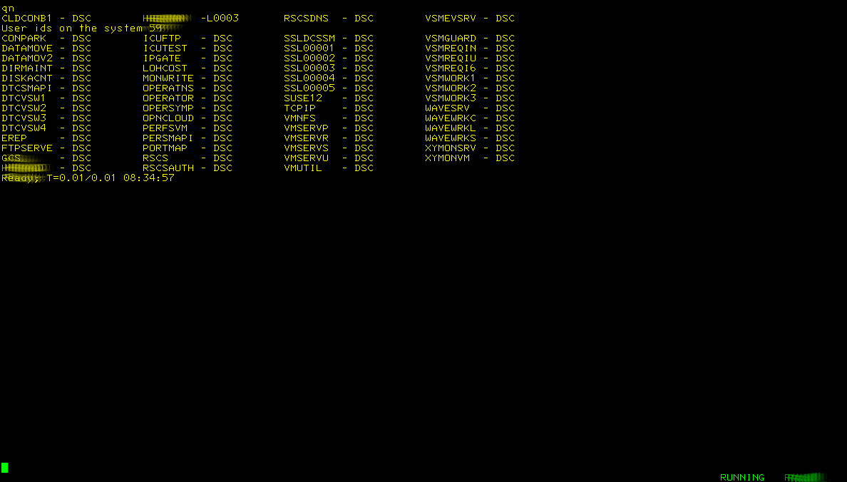

Hmmmm, I do not like where my count appeared...
/* QN EXEC, query names sorted, in 4 columns, aligned, cleaned & counted */
'PIPE (end ?)',
'cp QUERY NAMES', /* Ask CP who is logged on */
'| split at ,', /* Split the records at the comma */
'| strip', /* Remove spaces on both ends */
'| sort 1.8', /* Sort on user name */
'| pick w1.1 \== /VSM/ and', /* Select records were word 1 is not equal to.*/
'w3.1 \== /TCPIP/', /* ...and word 3 is not equal to... */
'| fo: fanout', /* Send the records to label fo: */
'| count lines', /* Count the ids */
'| specs /User ids on the system/ 1 w1.1 nw', /* Add some text */
'| fi: faninany', /* Take in from label fi: */
'| cons', /* Put the results on the console */
'? fo:', /* Take records from fanout */
'| specs pad space 1;* 1.22', /* Pad each record upto 22 chars */
'| snake 4', /* Create 4 columns */
'| buffer', /* Prevent stall/loop */
'| fi:' /* Send to faninany */

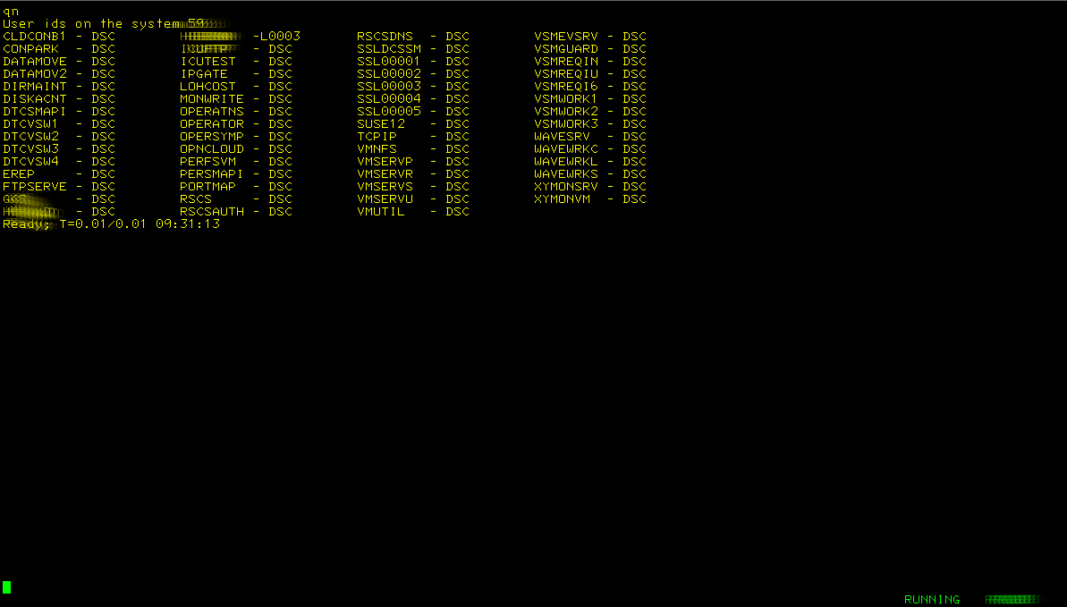
I wonder, which user ids are running that have the string DA in their name
/* QN version with search */
Parse Upper Arg search .
'PIPE (end ?)',
'cp QUERY NAMES', /* Ask CP who is logged on */
'| split at ,', /* Split the records at the comma */
'| strip', /* Remove spaces on both ends */
'| sort 1.8', /* Sort on user name */
'| pick w1.1 \== /VSM/ and', /* Select records were word 1 is not equal to... */
'w3.1 \== /TCPIP/', /* ...and word 3 is not equal to... */
'| locate /'search'/', /* Locate the string we are searching */
'| fo: fanout', /* Send the records to label fo: */
'| count lines', /* Count the ids */
'| specs /User ids on the system/ 1 w1.1 nw', /* Add some text */
'| fi: faninany', /* Take in from label fi: */
'| cons', /* Put the results on the console */
'? fo:', /* Take records from fanout */
'| specs pad space 1;* 1.22', /* Pad each record upto 22 chars */
'| snake 4', /* Create 4 columns */
'| buffer', /* Prevent stall/loop */
'| fi:' /* Send to faninany */

Playing about with the new code and doing various searches:
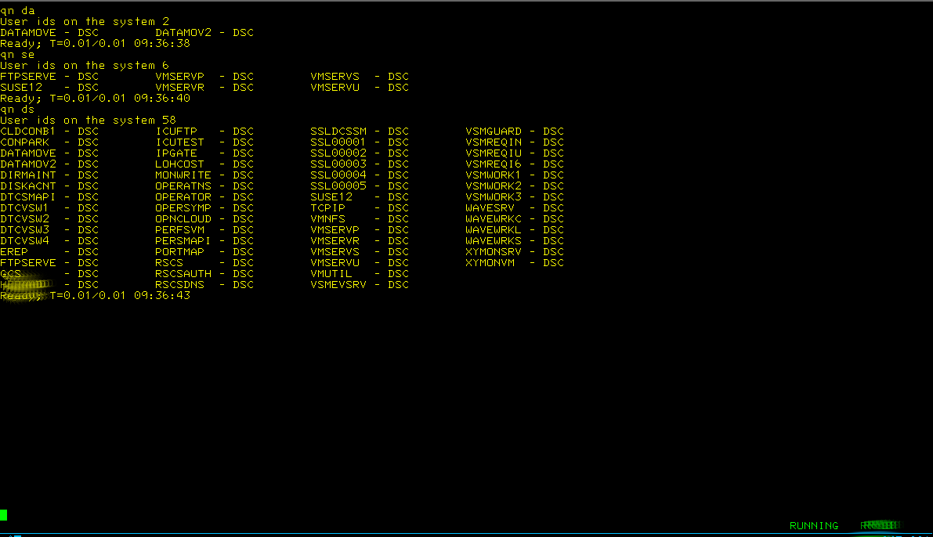

Oops the last run is definetely not what I wanted
/* QN version with search */
Parse Upper Arg search .
'PIPE (end ?)',
'cp QUERY NAMES', /* Ask CP who is logged on */
'| split at ,', /* Split the records at the comma */
'| strip', /* Remove spaces on both ends */
'| sort 1.8', /* Sort on user name */
'| pick w1.1 \== /VSM/ and', /* Select records were word 1 is not equal to... */
'w3.1 \== /TCPIP/', /* ...and word 3 is not equal to... */
'| locate w1.1 /'search'/', /* Locate the string we are searching */
'| fo: fanout', /* Send the records to label fo: */
'| count lines', /* Count the ids */
'| specs /User ids on the system/ 1 w1.1 nw', /* Add some text */
'| fi: faninany', /* Take in from label fi: */
'| cons', /* Put the results on the console */
'? fo:', /* Take records from fanout */
'| specs pad space 1;* 1.22', /* Pad each record upto 22 chars */
'| snake 4', /* Create 4 columns */
'| buffer', /* Prevent stall/loop */
'| fi:' /* Send to faninany */

Testing the improved code:
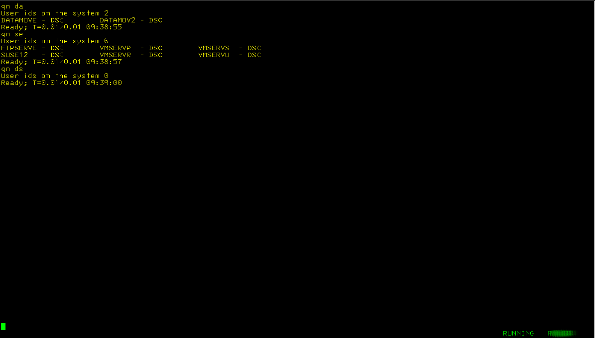
Now, would a wildcard work?


Mmmmm....implementing wildcards...how do we go about that
/* QN version with search and wildcard */
Parse Upper Arg search .
pipestmt=’’
If Pos('*',search)<>0 Then pipestmt='| wildcard w1.1 /'search'/'
Else pipestmt='| locate w1.1 /'search'/'
'PIPE (end ?)',
'cp QUERY NAMES', /* Ask CP who is logged on */
'| split at ,', /* Split the records at the comma */
'| strip', /* Remove spaces on both ends */
'| sort 1.8', /* Sort on user name */
'| pick w1.1 \== /VSM/ and', /* Select records were word 1 is not equal to... */
'w3.1 \== /TCPIP/', /* ...and word 3 is not equal to... */
pipestmt, /* Execute what was selected above */
'| fo: fanout', /* Send the records to label fo: */
'| count lines', /* Count the ids */
'| specs /User ids on the system matching ‘search’/ 1 w1.1 nw', /* Add some text */
'| fi: faninany', /* Take in from label fi: */
'| cons', /* Put the results on the console */
'? fo:', /* Take records from fanout */
'| specs pad space 1;* 1.22', /* Pad each record upto 22 chars */
'| snake 4', /* Create 4 columns */
'| buffer', /* Prevent stall/loop */
'| fi:' /* Send to faninany */

Now testing again:
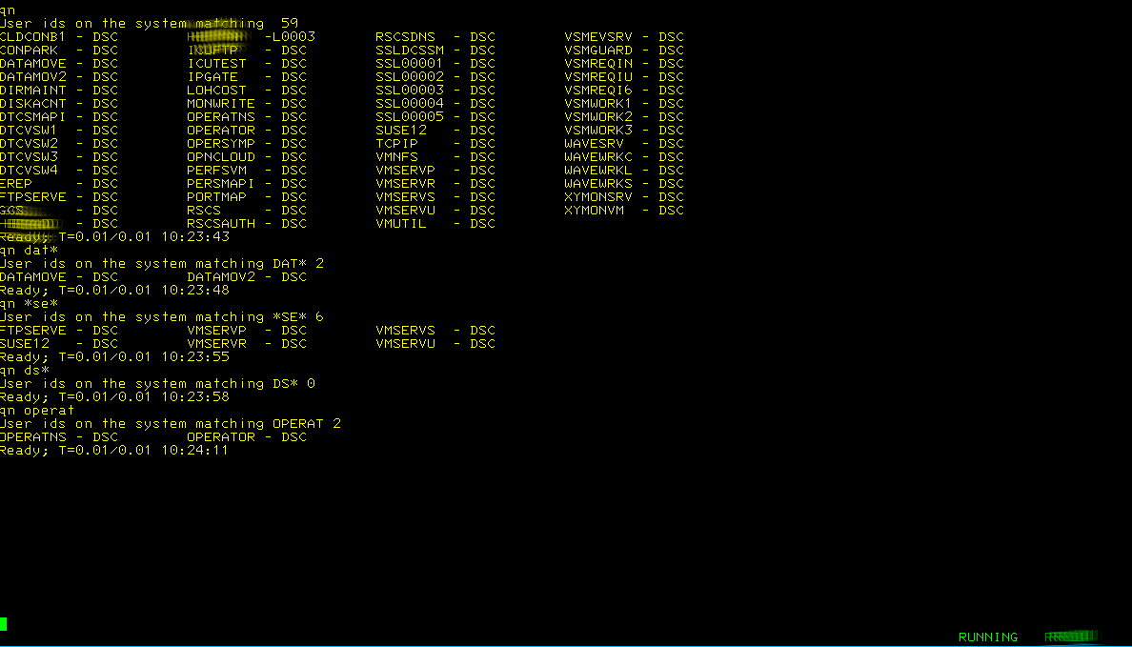
I wonder if I could add a count on first character of the user ids
/* QN version with wildcard, smartened */
Parse Upper Arg search .
pipestmt=''
If Pos('*',search)<>0 Then pipestmt='| wildcard w1.1 /'search'/'
Else pipestmt='| locate w1.1 /'search'/'
/* If search='' Then pipestmt='' */
'PIPE (end ?)',
'cp QUERY NAMES', /* Ask CP who is logged on */
'| split at ,', /* Split the records at the comma */
'| strip', /* Remove spaces on both ends */
'| sort 1.8', /* Sort on user name */
'| pick w1.1 \== /VSM/ and', /* Select records were word 1 is not equal to... */
'w3.1 \== /TCPIP/', /* ...and word 3 is not equal to... */
pipestmt, /* Content decided above */
'| fo: fanout', /* Send the records to label fo: */
'| count lines', /* Count the ids */
'| specs /User ids on the system matching 'search'/ 1 w1.1 nw', /* Add some text */
'| fi1: faninany', /* Take in from label fi: */
'| cons', /* Put the results on the console */
'? fo:', /* Take records from fanout */
'| fi2: faninany', /* Take in stuff from fi2: */
'| sort', /* Sort them */
'| specs pad space 1;* 1.22', /* Pad each record upto 22 chars */
'| snake 4', /* Create 4 columns */
'| buffer', /* Prevent stall/loop */
'| fi1:', /* Send to faninany */
'? fo:', /* Take records from fanout */
'| specs 1.1 1 1;* nw', /* Add 1st char as separate word */
'| sort count 1.1', /* Count them */
'| specs 11.1 1 1.10 nw', /* Rework the output */
'| specs w1.1 1.1 w2.1 nw.2 right', /* Adjust numbers */
'| fi2:' /* Send to faninany w label fi2: */

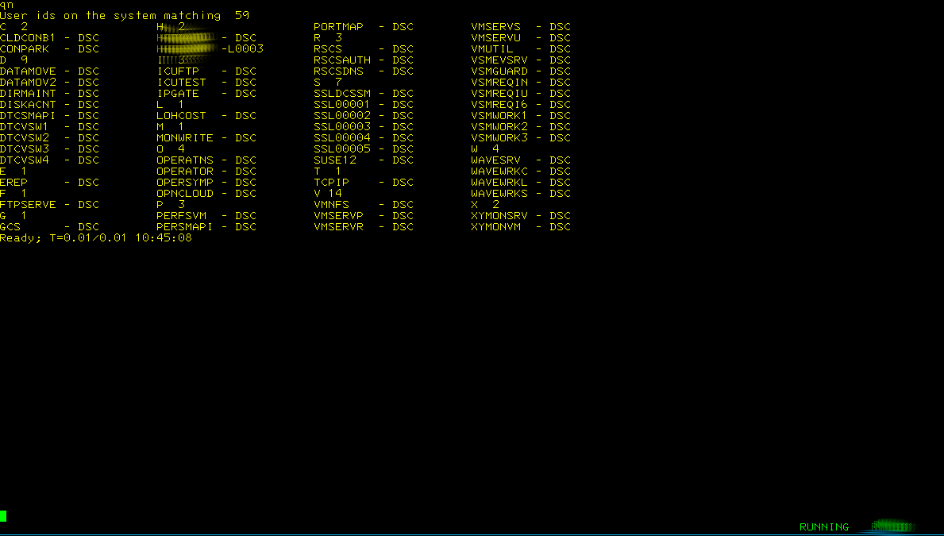
Not as smart as I would like
/* QN version with wildcard, smartened & improved */
Parse Upper Arg search .
pipestmt=''
If Pos('*',search)<>0 Then pipestmt='| wildcard w1.1 /'search'/'
Else pipestmt='| locate w1.1 /'search'/'
/* If search='' Then pipestmt='' */
'PIPE (end ?)',
'cp QUERY NAMES', /* Ask CP who is logged on */
'| split at ,', /* Split the records at the comma */
'| strip', /* Remove spaces on both ends */
'| sort 1.8', /* Sort on user name */
'| pick w1.1 \== /VSM/ and', /* Select records were word 1 is not equal to... */
'w3.1 \== /TCPIP/', /* ...and word 3 is not equal to... */
pipestmt, /* Content decided above */
'| fo: fanout', /* Send the records to label fo: */
'| count lines', /* Count the ids */
'| specs /User ids on the system matching 'search'/ 1 w1.1 nw', /* Add some text */
'| fi1: faninany', /* Take in from label fi: */
'| cons', /* Put the results on the console */
'? fo:', /* Take records from fanout */
'| fi2: faninany', /* Take in stuff from fi2: */
'| sort', /* Sort them */
'| if: if pick w3.1 == °*°', /* If word 3 equals * */
'| specs w3.1 1 w1.2 nw', /* ...we rework the record */
'| if:', /* End of if */
'| specs pad space 1;* 1.22', /* Pad each record upto 22 chars */
'| snake 4', /* Create 4 columns */
'| buffer', /* Prevent stall/loop */
'| fi1:', /* Send to faninany */
'? fo:', /* Take records from fanout */
'| specs 1.1 1 1;* nw', /* Add 1st char as separate word */
'| sort count 1.1', /* Count them */
'| specs 11.1 1 1.10 nw', /* Rework the output */
'| specs w1.1 1.1 w2.1 nw.2 right °*° nw', /* Adjust numbers */
'| fi2:' /* Send to faninany w label fi2: */
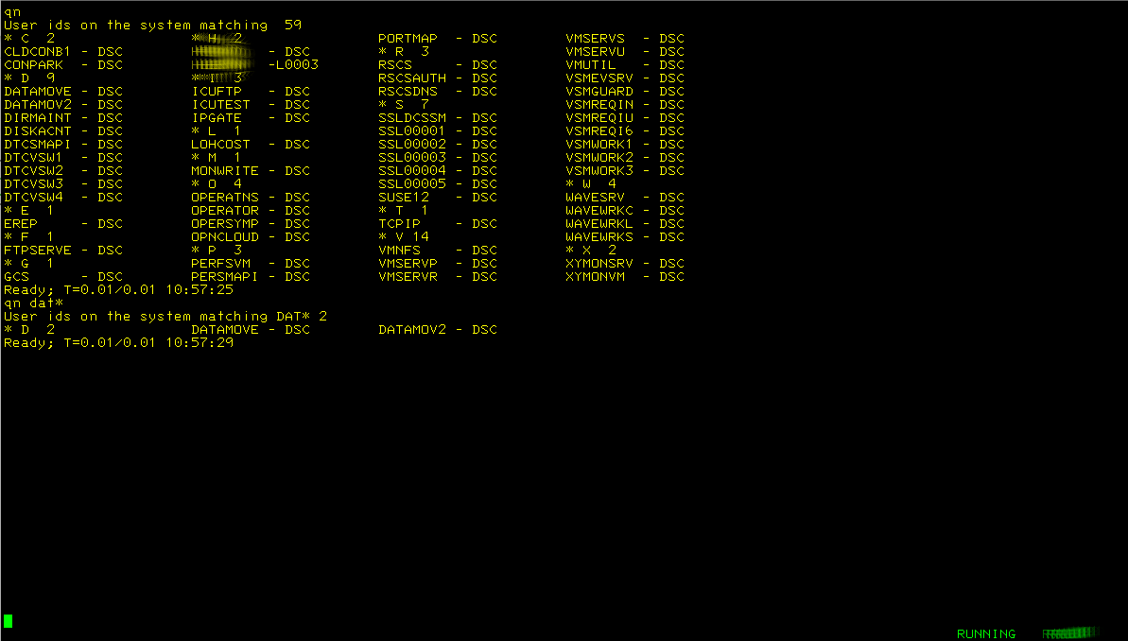
Much better but I am still not completely happy, let’s see what we can do
/* QN version with wildcard, smartened & improved */
Parse Upper Arg search .
pipestmt=''
If Pos('*',search)<>0 Then pipestmt='| wildcard w1.1 /'search'/'
Else pipestmt='| locate w1.1 /'search'/'
/* If search='' Then pipestmt='' */
'PIPE (end ?)',
'cp QUERY NAMES', /* Ask CP who is logged on */
'| split at ,', /* Split the records at the comma */
'| strip', /* Remove spaces on both ends */
'| sort 1.8', /* Sort on user name */
'| pick w1.1 \== /VSM/ and', /* Select records were word 1 is not equal to... */
'w3.1 \== /TCPIP/', /* ...and word 3 is not equal to... */
pipestmt, /* Content decided above */
'| fo: fanout', /* Send the records to label fo: */
'| count lines', /* Count the ids */
'| specs /User ids on the system matching 'search'/ 1 w1.1 nw', /* Add some text */
'| fi1: faninany', /* Take in from label fi: */
'| cons', /* Put the results on the console */
'? fo:', /* Take records from fanout */
'| fi2: faninany', /* Take in stuff from fi2: */
'| sort', /* Sort them */
'| if: if pick w3.1 == °*°', /* If word 3 equals * */
'| specs w3.1 1 w1.2 nw.18', /* ...we rework the record */
'| if:', /* Else section of if */
'| specs pad space 1;* 3.18', /* Pad each record upto 22 chars */
'| if:', /* End of if */
'| snake 4', /* Create 4 columns */
'| buffer', /* Prevent stall/loop */
'| fi1:', /* Send to faninany */
'? fo:', /* Take records from fanout */
'| specs 1.1 1 1;* nw', /* Add 1st char as separate word */
'| sort count 1.1', /* Count them */
'| specs 11.1 1 1.10 nw', /* Rework the output */
'| specs w1.1 1.1 w2.1 nw.2 right °*° nw', /* Adjust numbers */
'| fi2:' /* Send to faninany w label fi2: */

